Lesson 6 Reteach

Fluently Add and Subtract Rational Numbers: Unlike Fractions

To add or subtract fractions with different denominators,
• Rename the fractions using the least common denominator (LCD).
• Add or subtract as with like fractions.
• If necessary, simplify the sum or difference.

Example
Determine $\frac{2}{3}+\frac{1}{4}$.
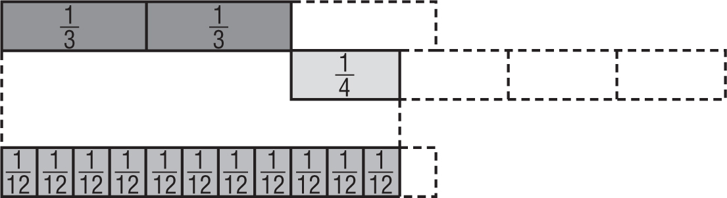
Method 1 Use a model.
$\frac{2}{3}$
$+ \frac{1}{4}$
$\frac{11}{12}$

Method 2 Use the LCD.
$\frac{2}{3}+\frac{1}{4}=\frac{2}{3}•\frac{4}{4}+\frac{1}{4}•\frac{3}{3}$ Rename using the LCD, 12.
$=\frac{8}{12}+\frac{3}{12}$ or $\frac{11}{12}$ Add the fractions.

Exercises
Add or subtract. Express in simplest form.
1. $\frac{1}{2}+\frac{3}{4}$ 2. $\frac{3}{8}-\frac{1}{2}$

3. $\frac{7}{15}+\left(-\frac{5}{6}\right)$ 4. $\frac{2}{5}-\frac{1}{3}$

5. $\frac{5}{9}+\left(-\frac{5}{12}\right)$ 6. $\frac{11}{12}-\frac{3}{4}$

7. $\frac{7}{8}-\left(-\frac{1}{3}\right)$ 8. $\frac{7}{9}-\frac{1}{2}$

9. $\frac{3}{10}+\frac{7}{12}$ 10. $\frac{3}{5}+\frac{2}{3}$

