Lesson 5 Reteach

Fluently Add and Subtract Rational Numbers: Like Fractions

Like fractions are fractions that have the same denominator. To add or subtract like fractions, add or subtract the numerators and write the result over the denominator.
Simplify if necessary.

Example 1
Determine $\frac{3}{4}+\frac{1}{4}$. Express in simplest form.
$\frac{3}{4}+\frac{1}{4}=\frac{3 + 1}{4}$ Add the numerators.
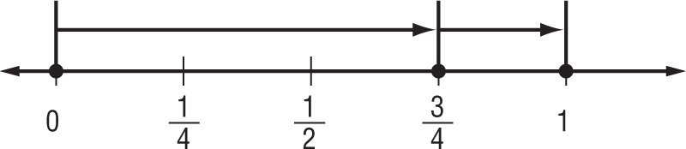
$=\frac{4}{4}$ Write the sum over
the denominator.
= 1 Simplify.

Example 2
Determine $\frac{2}{3}-\frac{1}{3}$. Express in simplest form.
$\frac{2}{3}-\frac{1}{3}=\frac{2 - 1}{3}$ Subtract the numerators.
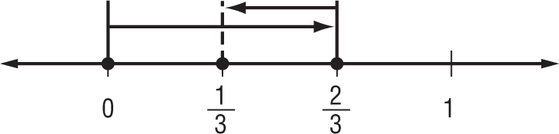
$=\frac{1}{3}$ Write the difference over
the denominator.

Exercises
Add or subtract. Express in simplest form.
1. $\frac{5}{8}+\frac{1}{8}$ 2. $\frac{7}{9}-\frac{2}{9}$

3. $-\frac{1}{4}+\frac{3}{4}$ 4. $\frac{7}{8}-\frac{5}{8}$

5. $\frac{5}{9}+\frac{5}{9}$ 6. $-\frac{3}{8}-\frac{1}{8}$

7. $\frac{3}{10}+\frac{1}{10}$ 8. $\frac{2}{5}-\frac{1}{5}$

9. $\frac{7}{15}+\frac{4}{15}$ 10. $\frac{7}{9}-\frac{8}{9}$

