Dear Parents/Students,

Please read below to find out what supplies you will need to bring to class during the FIRST WEEK of school. Unless otherwise mentioned, all supplies will be turned into your math teacher and used as community supplies throughout the school year.
Thank you for your help!

- 2 boxes of tissue
- 2 rolls of Scotch Tape
- pack of Crayola glue sticks
- 2 packs of 8-10 count Crayola markers
- Hand sanitizer
- 1 roll of 2" heavy duty clear packing tape
- 24 pack of #2 pencils
- 2 Composition Notebooks

**NOT spirals, composition books are the black and white bound notebooks and will be used the 2nd day of school. (Colors and designs are accepted as long as school appropriate)

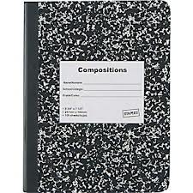

Mrs. Brewer, 7th Grade Math Teacher

