PreAP Homework due Friday, January 13, 2017

Angle Relationships

1. The time shown on the clock is :05.Starting at this time, approximately what time will it be when the hands form an obtuse angle? | 2. The runways at a local airport are sketched in the figure. Classify ∠1 and ∠2 as acute, obtuse, right,  or straight.  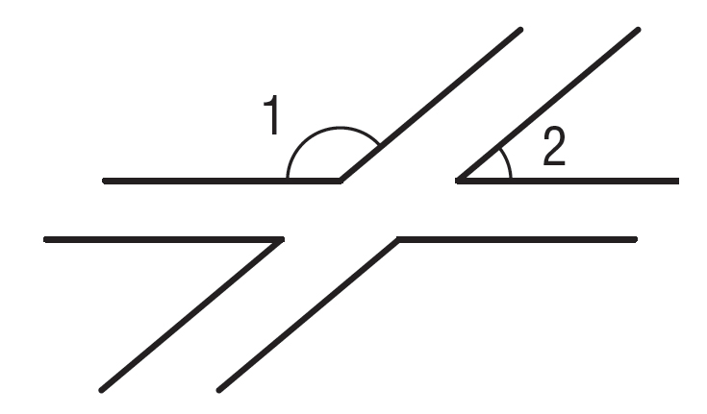
3. Which of the following letters contain at least one acute angle? Which contain vertical angles? Which contain adjacent angles?  A E L X | 4. The time shown on the clock is 12:07. After 20 minutes have passed, will the angle formed by  the hour and minute hands be acute, obtuse, right,  or straight?
5. When a ballet dancer’s feet are in first position, the heels are touching, and the feet are turned out. A dancer with excellent technique can position his or her feet so that they are nearly in a straight line. Isabella is practicing her technique. Classify the angle her feet form as acute, obtuse, or right.  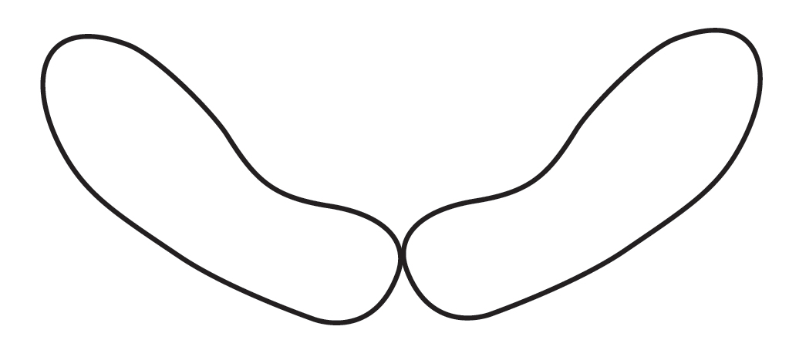 | 6. The plans for a new aquarium call for 2 hallways of exhibits leading out of a circular main room as shown. What is the value of x?  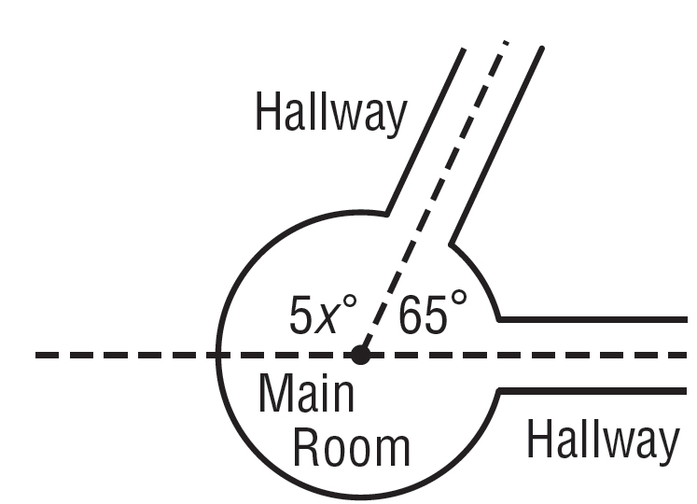

Complementary and Supplementary Angles

1. A side view of the Great Pyramid at Giza is shown below. The sides of the pyramid make an angle of 52˚ with respect to the ground. What is the value of x?  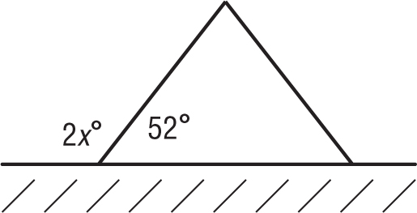 | 2. A map shows a railroad crossing a highway, as shown below. Which of the numbered angles are supplementary angles?  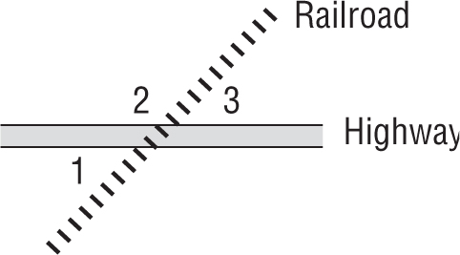
3. Refer to the map shown in Exercise 2. If m∠1 is 64˚, what is the measure of ∠2? | 4. A ski jump makes an angle of 27˚ with respect to the water as shown below. How are the 27˚ angle and the unknown angle related? What is the value of x?  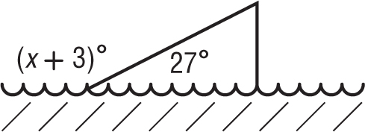
5. A kite string makes an angle of 48˚ with respect to the ground as shown below. The dashed line is vertical and the ground is horizontal. How are the 48˚ angle and the unknown angle related? What is the value  of x?  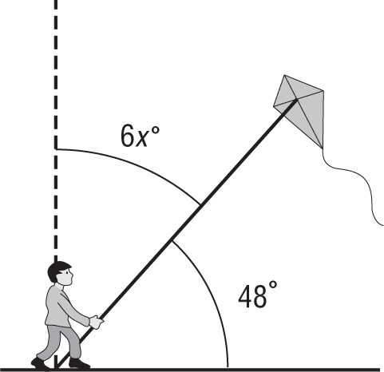 | 6. In a game of pick-up-sticks, the last 4 sticks are shown below. Which of the numbered angles are supplementary angles?  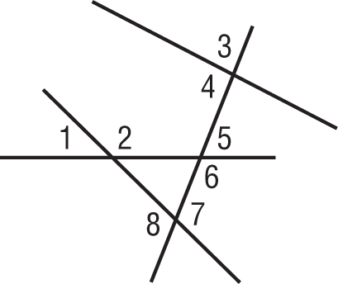

Circumference

For Exercises 1–3, use the table that shows the sizes of three main audio media: vinyl, CD, and mini-disc.
Diameters of Audio Media
Medium | Diameter (inches)
Vinyl Disc | 12
Compact Disc (CD) | 5
Mini Compact Disc (Mini-Disc) | 2.5

1. Determine the circumference of a CD. Use 3.14 for π. | 2. When a record player needle is placed on the outside edge of a vinyl disc, determine how far the needle travels in one rotation. Use 3.14 for π. Round to the nearest tenth.
3. What is the difference between the circumference of a vinyl disc and a mini-disc? Use 3.14 for π. Round to the nearest tenth. | 4. On June 8, 1992, a crop circle with an 18-meter radius was found in a wheat field near Szekesfehervar, 43 miles southwest of Budapest. Determine its circumference. Use 3.14 for π.

Area of Composite Figures
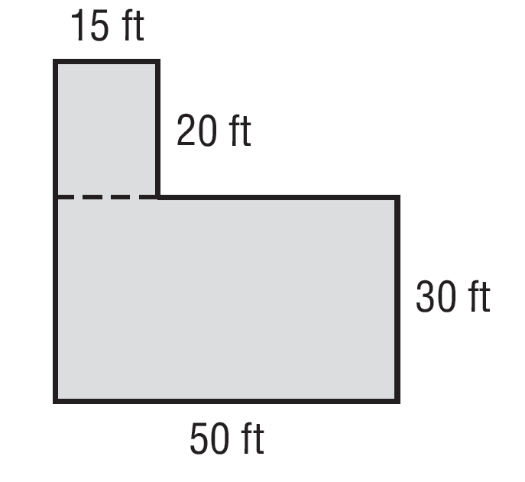
For Exercises 1 and 2 use the diagram of a yard and the following information. The figure shows the measurements of Buzz’s yard which he intends to sod.

1. Determine the area of the yard. | 2. One pallet of sod covers 400 square feet. How many full pallets of sod will Buzz need to buy to have enough for his entire yard?
3. Leeor was asked to repaint the sign for his mother’s ice cream shop, so he needs to figure out how much paint he will need. Determine the area of the ice cream cone on the sign. Round to the nearest tenth.  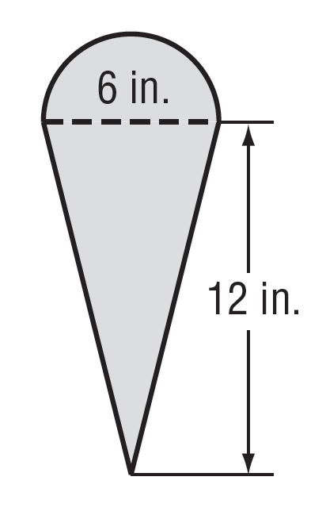 | 4. Ward is planning to install a new countertop in his kitchen, as shown in the figure. Determine the area of the countertop.  