PreAP Homework due Friday, October 7, 2016

Constant Rate of Change

For Exercises 1 and 2, use the graph that shows the depth of the water in a vase of flowers over 8 days.
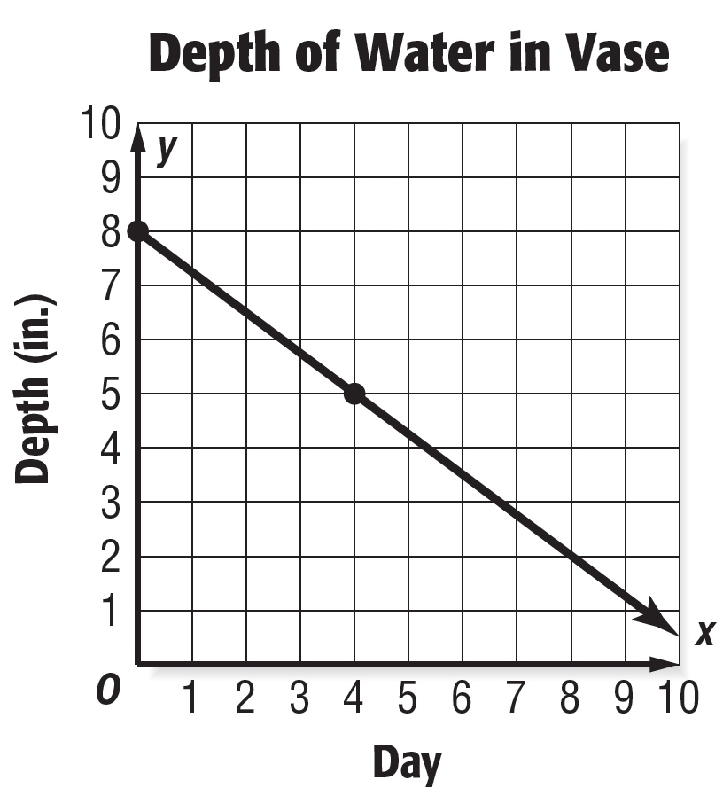
For Exercises 3–6, use the graph that compares the costs of long distance phone calls with three different companies.

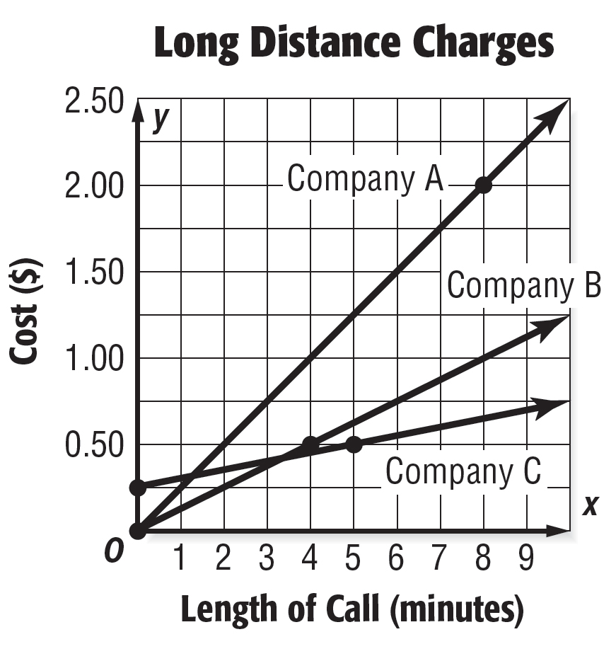

1. Determine the constant rate of change for the line. | 2. Interpret the relationship between depth in inches and the day.
3. Interpret the relationship between the cost in dollars and the length in minutes for Company A then write as a constant rate of change. | 4. Interpret the relationship between the cost in dollars and the length in minutes for Company B then write as a constant rate of change.
5. Interpret the relationship between the cost in dollars and the length in minutes for Company C then write as a constant rate of change. | 6. Which company charges the least for each additional minute? Explain your reasoning.

Slope

1. By the end of its first week, a movie had grossed $2.3 million. By the end of its sixth week, it had grossed $6.8 million. Graph the data with the week on the horizontal axis and the revenue on the vertical axis, and draw a line through the points. Then determine and interpret the slope of the line.  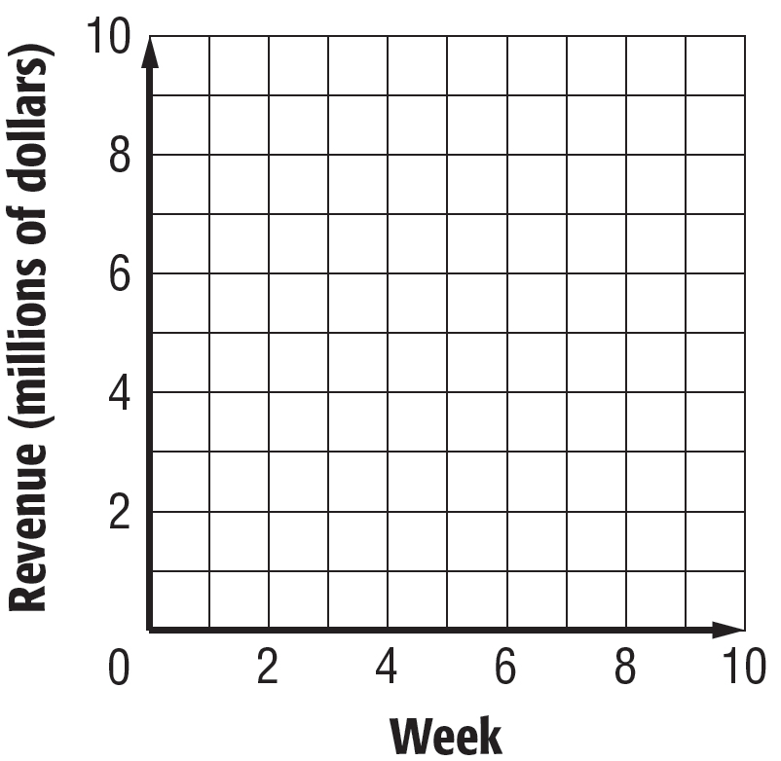 | 2. After Game 1, Felicia had scored 14 points. After Game 5, she had scored a total of 82 points for the season. After Game 10, she had scored 129 points. Graph the data with the game number on the horizontal axis and the number of points on the vertical axis. Connect the points using two different line segments.  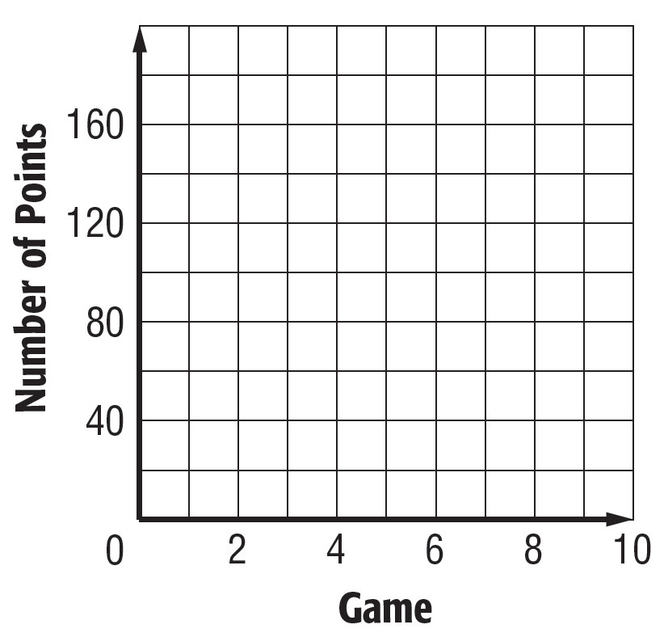
3. Determine the slope of each line segment in your graph from Exercise 2 and interpret it. Which part of the graph shows the greater rate of change? Explain. | 4. The figure shows triangle ABC plotted on a coordinate plane. Explain how to determine the slope of the line through points A and B. Then determine the slope.  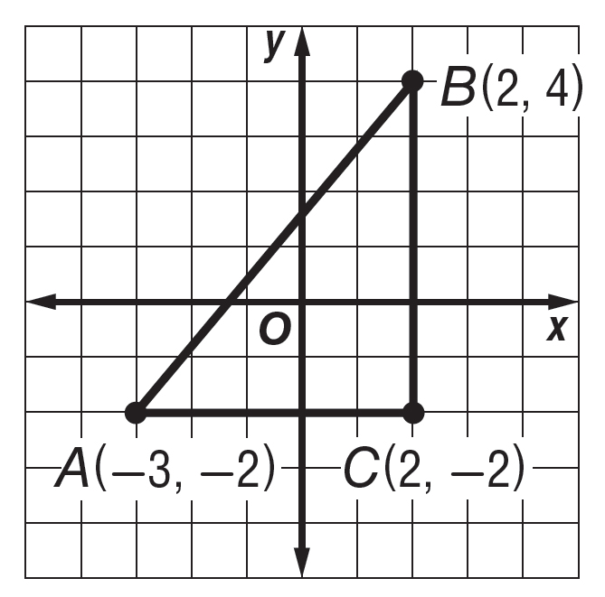
5. Use the figure in Exercise 4. What is the slope of the line through points A and C? How do you know? | 6. Use the figure in Exercise 4. What is the slope of the line through points B and C? How do you know?

